Bahria University,

Karachi Campus



LAB EXPERIMENT NO.

**02**

LIST OF TASKS

|  |  |
| --- | --- |
| TASK NO | OBJECTIVE |
| 01 | Write a program that takes any integer as input, and then fulfill the following conditions:  - If input < 2, print input  - Else if input = 2, then halt  - Else if a > 2, then halt |
| 02 | Write a program that takes any number as input, and then perform following calculations:  - If number < 10, add 100 in it and print result  - Else if number >=10, subtract 100 from it and print result |
| 03 | Write a program that takes two numbers as input and then print the smaller one. |
| 04 | Write a program that takes two hardcoded values, and then print the larger one. |

Submitted On:

**Date: 02/10/2023**

**Task No. 01:**Write a program that takes any integer as input, and then fulfill the following conditions:

- If input < 2, print input

- Else if input = 2, then halt

- Else if a > 2, then halt

**Solution:**

**Output:**

**- If input < 2, print input**

Figure Hardware View

Figure Trace View

**- Else if input = 2, then halt**

Figure Hardware View

Figure Trace View

**- Else if a > 2, then halt**

Figure Hardware View

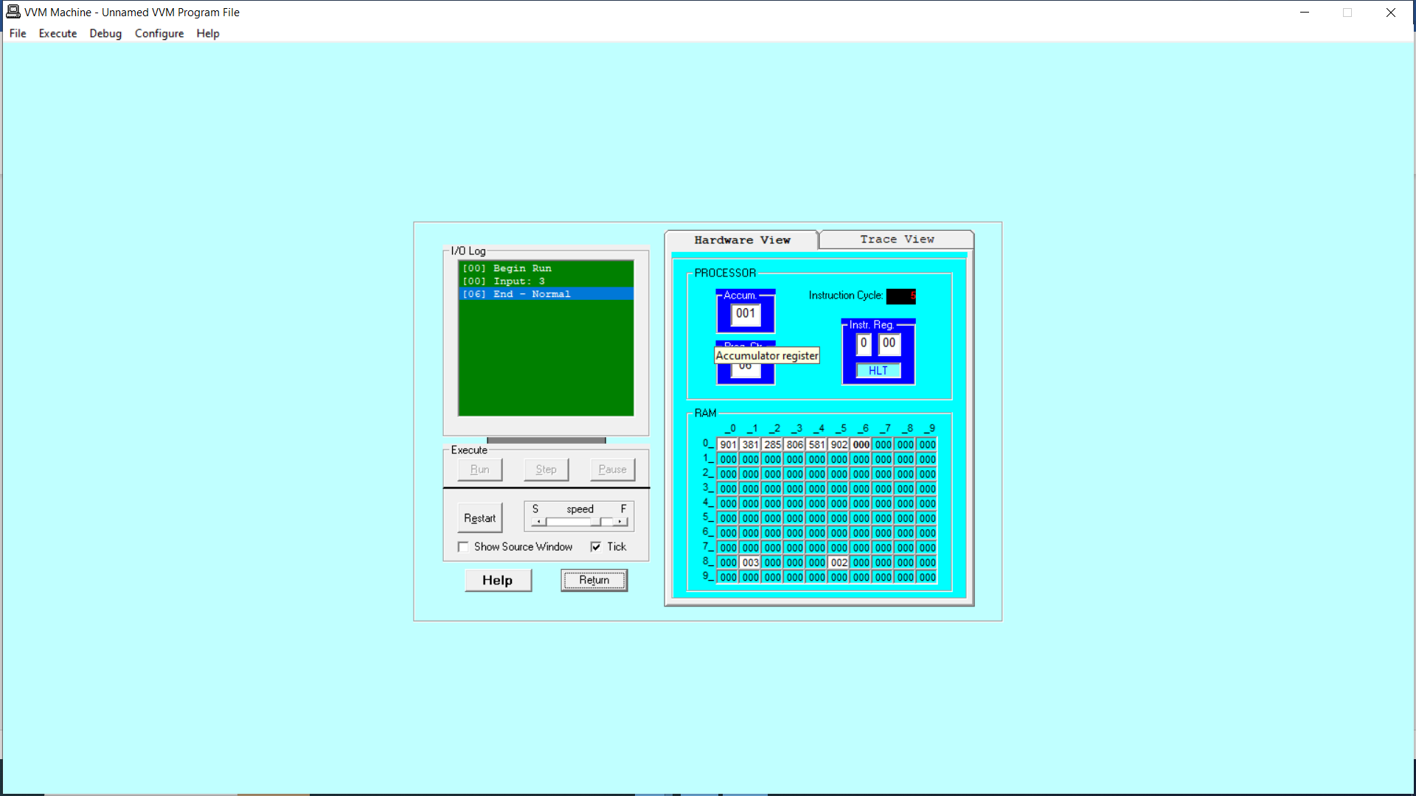

*Figure 6 Trace View*

**Task No. 02:** Write a program that takes any number as input, and then perform following calculations:

- If number < 10, add 100 in it and print result

- Else if number >=10, subtract 100 from it and print result

**Solution:**

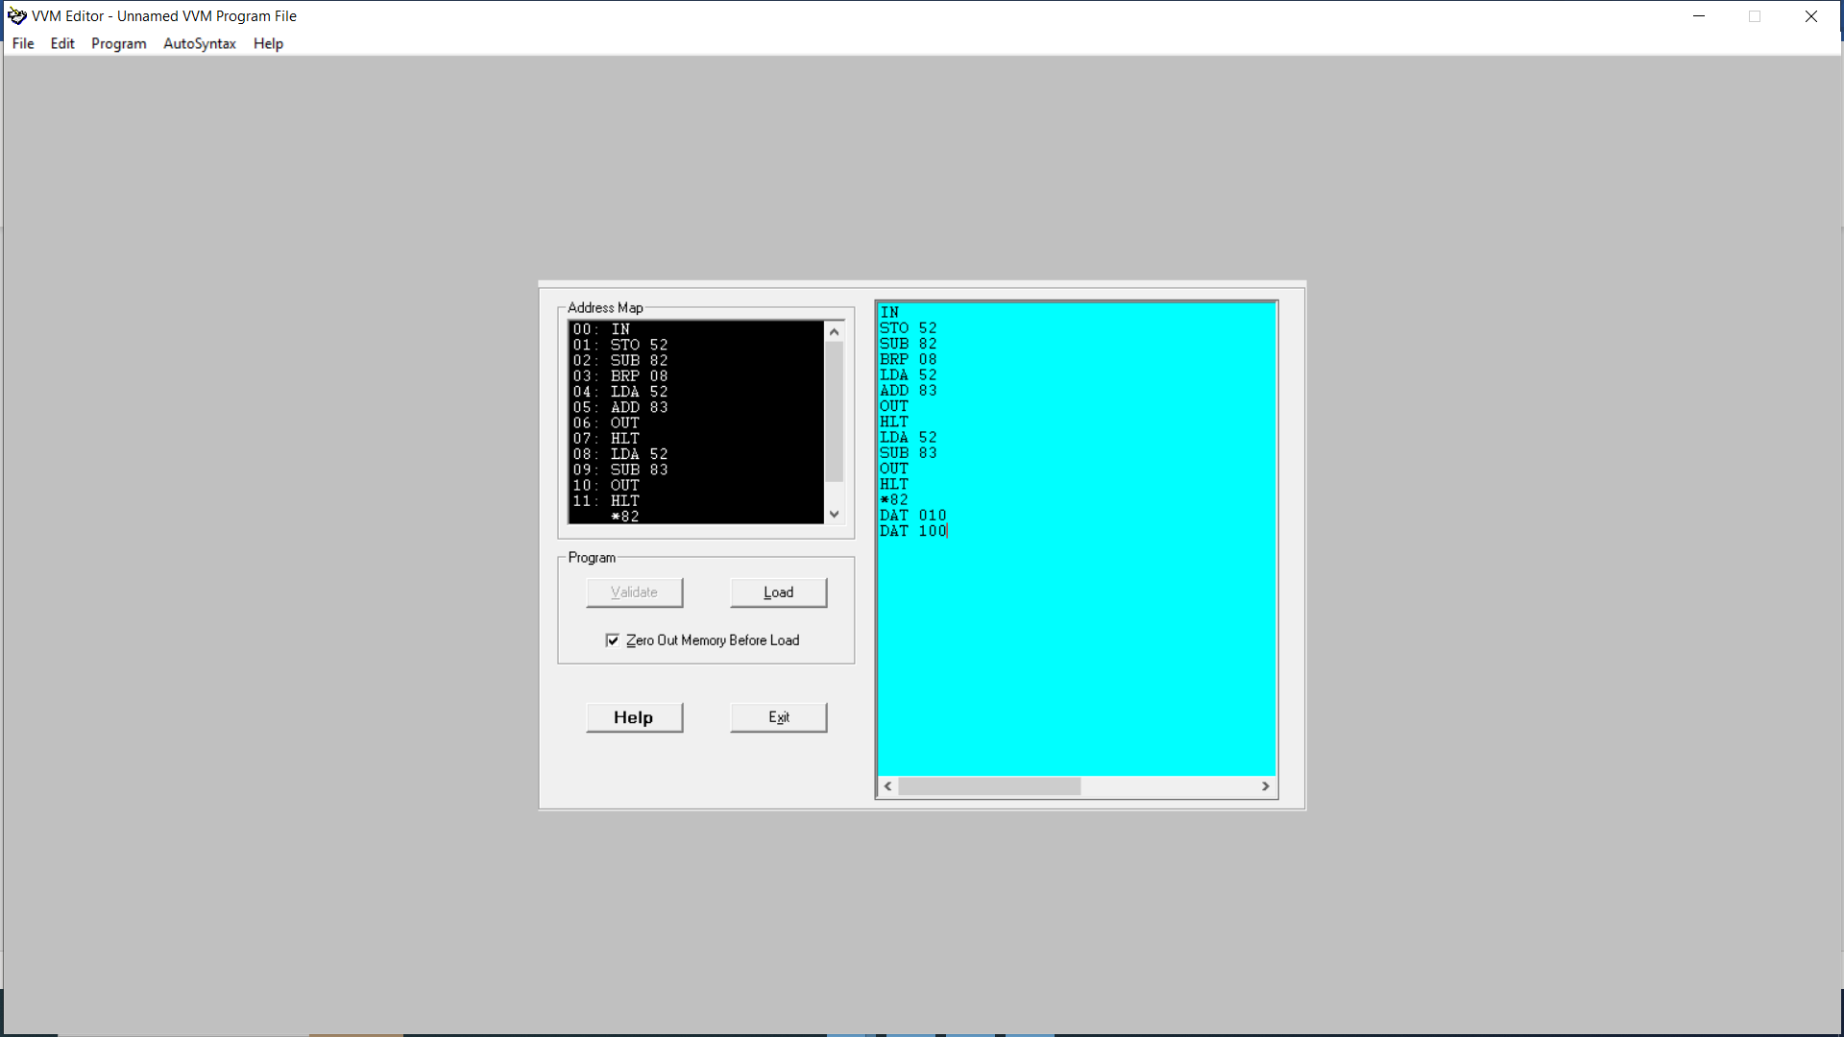

**Output:**

**- If number < 10, add 100 in it and print result**

Figure 1 Hardware View

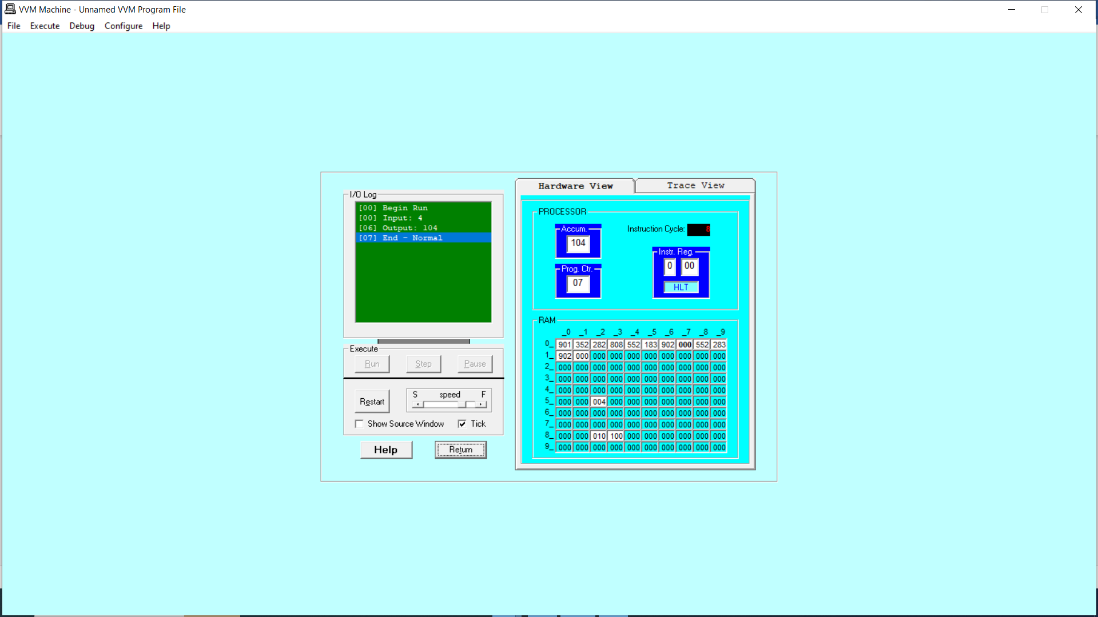

*Figure 7 Trace View*

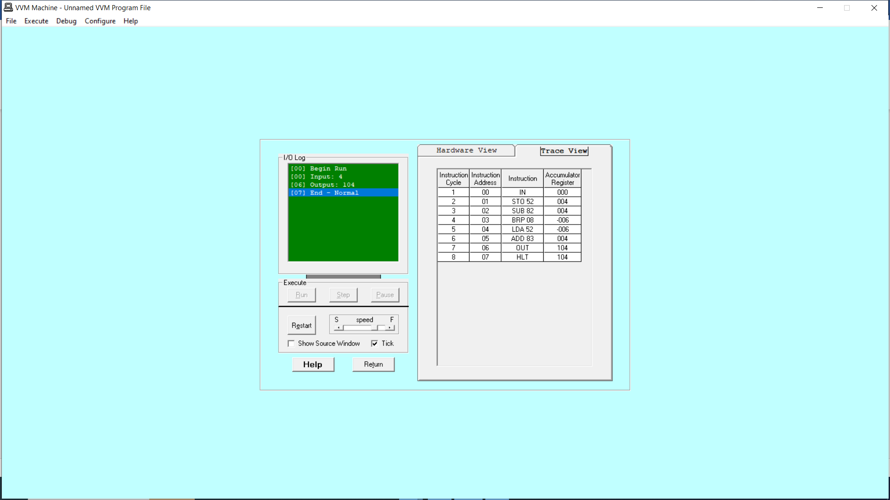

**- Else if number >=10, subtract 100 from it and print result**

Figure 1 Hardware View

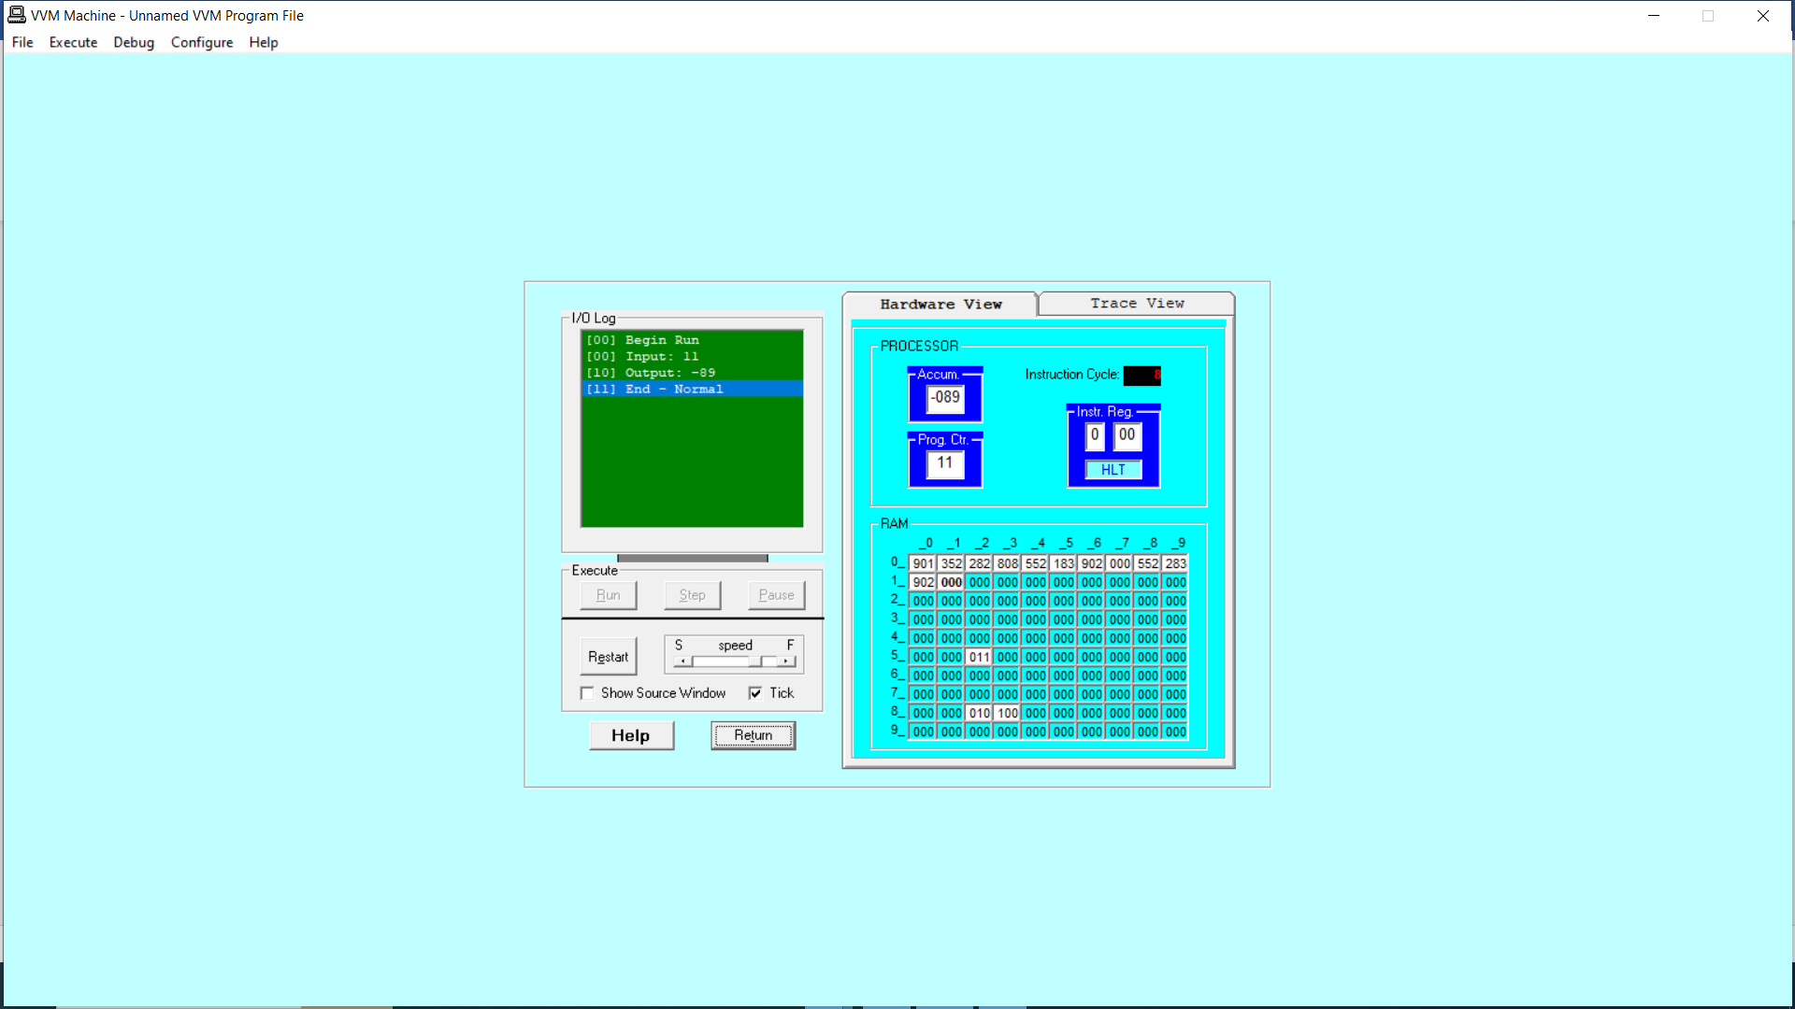

*Figure 8 Trace View*

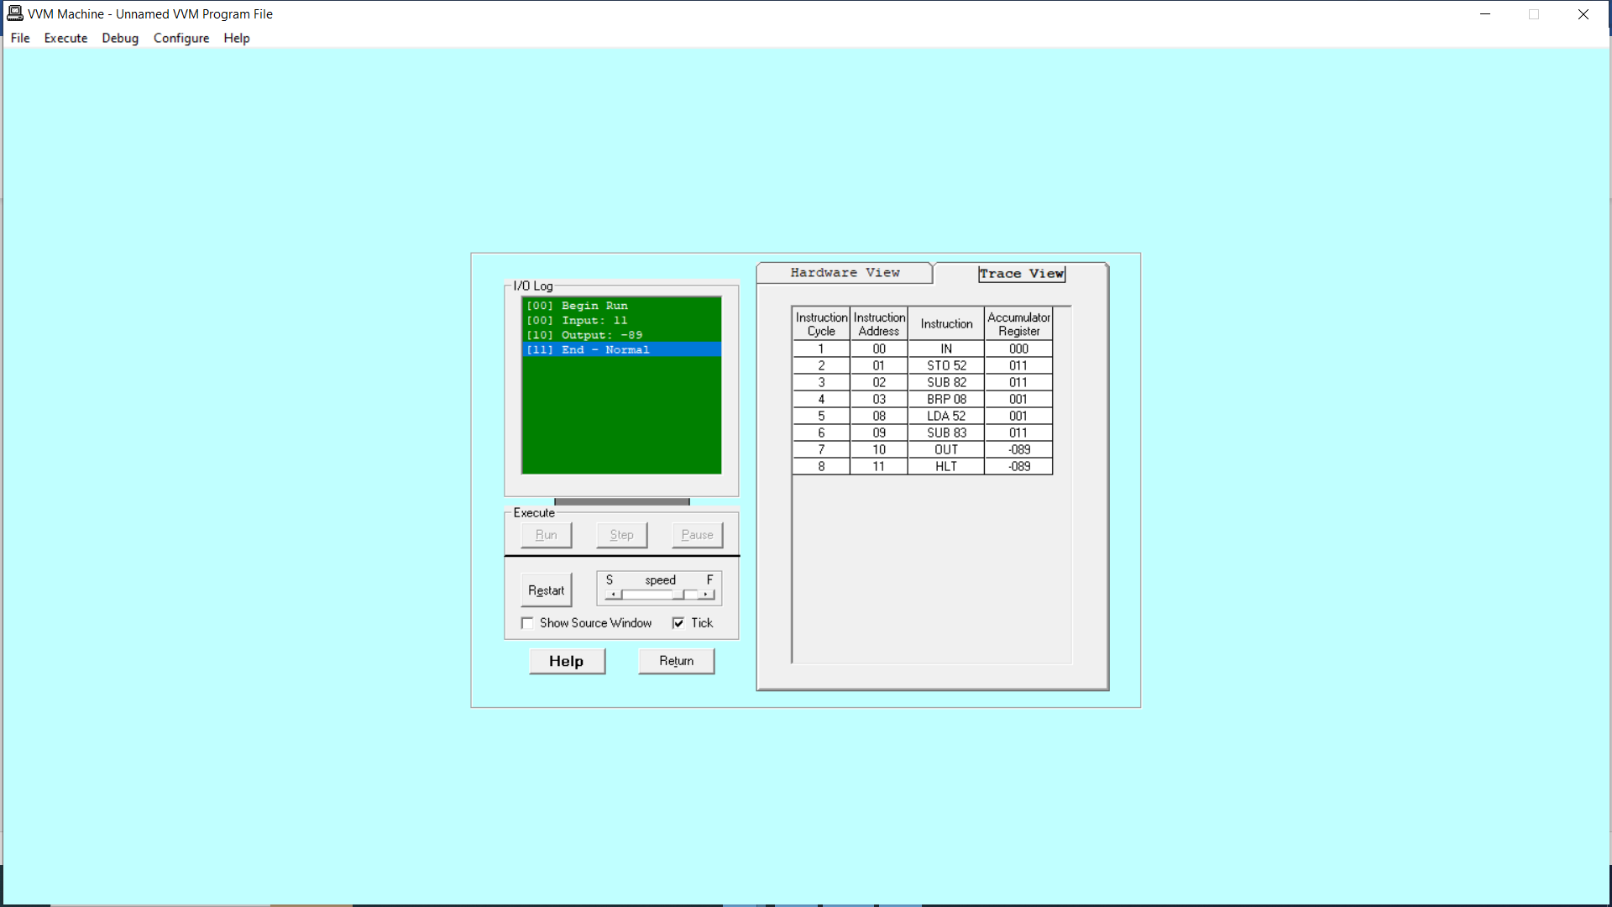

**Task No. 03:** Write a program that takes two numbers as input and then print the smaller one.

**Solution:**

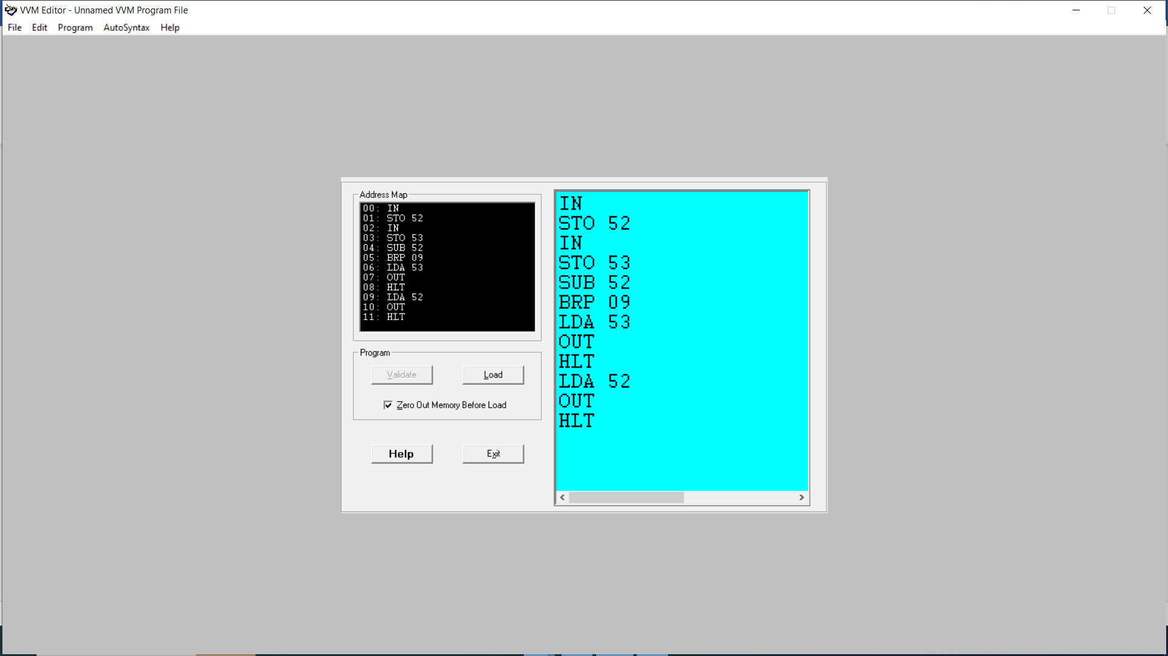

**Output:**

Figure 1 Hardware View

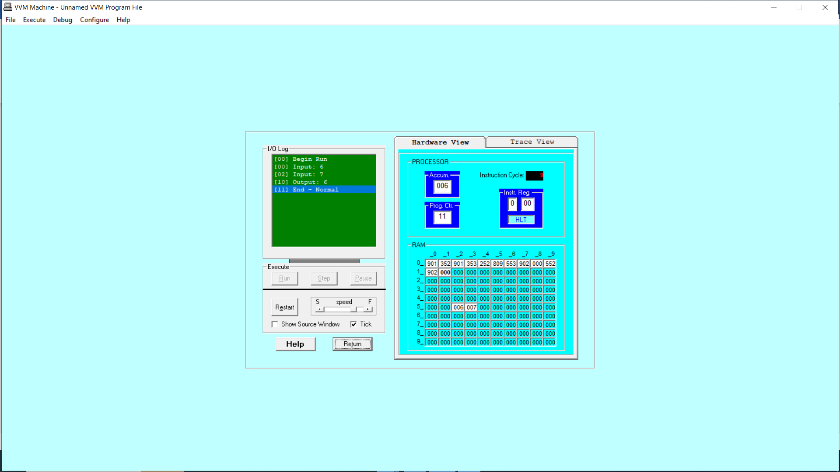

*Figure 9 Trace View*

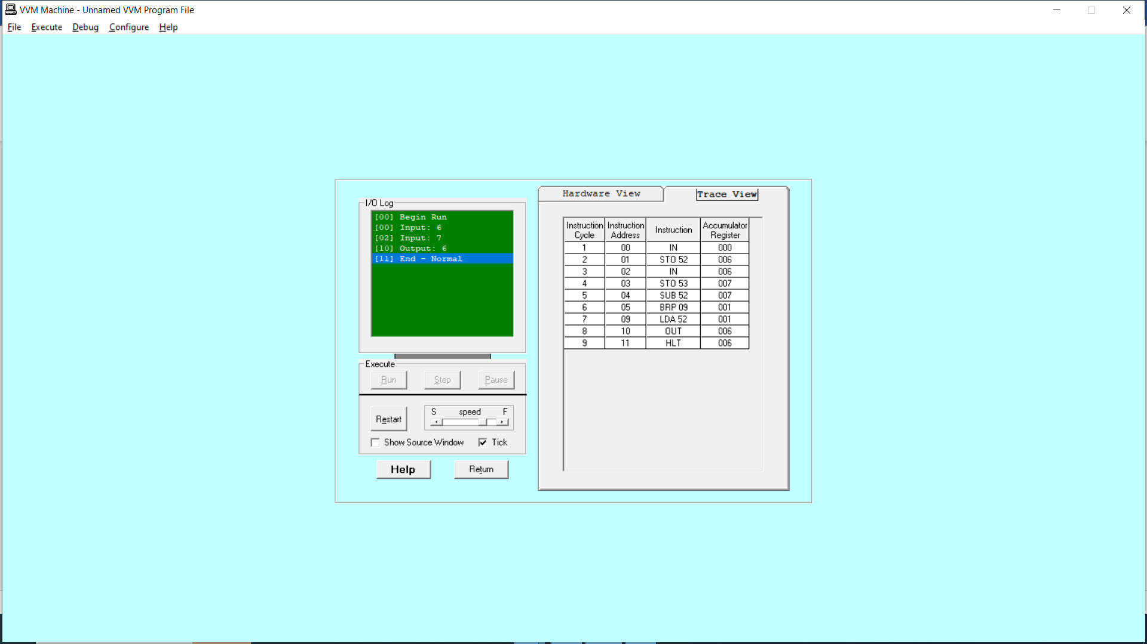

**Task No. 04:** Write a program that takes two hardcoded values, and then print the larger one.

**Solution:**

**Output:**

Figure 1 Hardware View

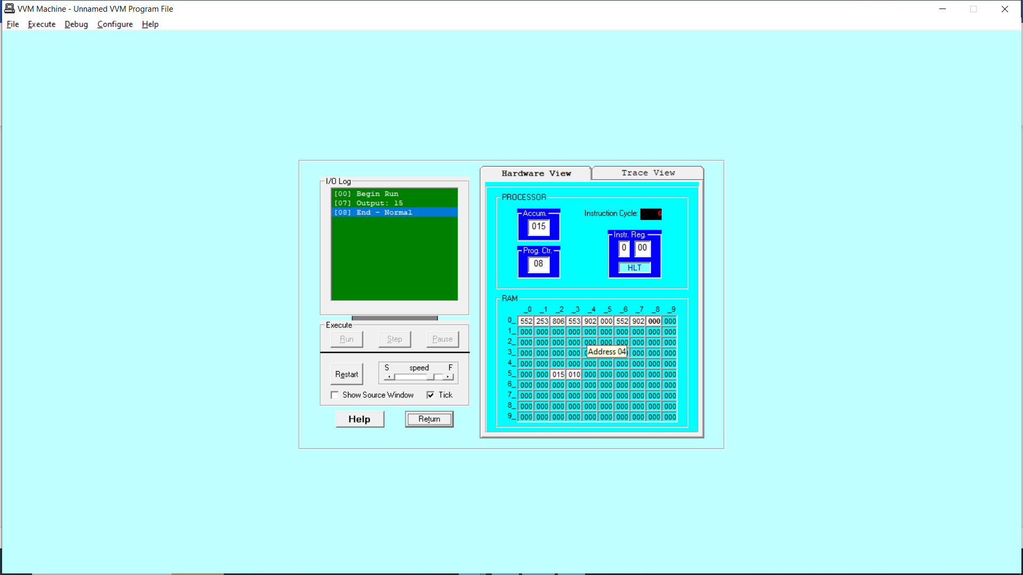

*Figure 10 Trace View*